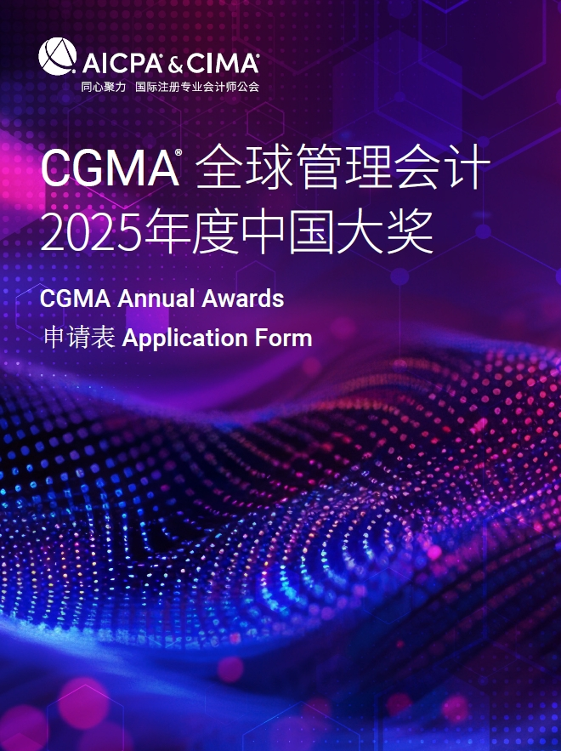

**CGMA Finance Leader of the Year**

This award goes to senior financial leaders based in China who have made a significant contribution to the success of their organization. The candidates shall have been in the same management role for at least one year. They rely on their dedication and outstanding leadership to make the continuous progress of the company, and they lead the company to move forward in a challenging era. Their skills and dedication have led to both strategic and financial achievements, demonstrating the highest standards of management accounting.

**年度财界领袖**

本奖项授予在中国为企业的成功做出杰出贡献的财务领导者，在目前的管理职位上任职超过一年。他们凭借对事业的专注与出众的领导力推动企业持续进步，能够在充满挑战的时代中带领企业砥砺前行。他们的技能与奉献创造了战略和财务上的成就，同时也体现出了管理会计的最高水准。

Candidates must be Chief Financial Officers, Heads of Finance, or equivalent senior financial management position and to have been in their current role for at least one year. They should also have been in the same industry sector for a minimum of three years.

参选人必须现任首席财务官、财务总监或其他财务管理岗位，并且在目前职位上任职超过一年，此外在同一行业至少有三年以上的就职经验。

The judges will be looking for a combination of professional and personal qualities together with a record of outstanding achievement.

评委会将综合考评其专业能力与个人素质，并对照其杰出成就进行评定。

**Rules of Entry**

**参赛规则**

1. Each entry must attach one resume in both English and Chinese for judges’reference.

每位参选人必须提交一份中英文简历供评委参考

2. Each entry must be submitted on a fully completed application form in both English and Chinese.

每位参选人必须提交一份完整的中英文申请表

3. The judges' decision will be final and no correspondence will be entered in the judging process.

评委会的决定为最终决定，在评委决定过程前后不得有任何通信联系

4. The application form should be submitted online by uploading at https://awards2025.cncima.com before the closing date of 10:00 (Beijing time) on 30th ,Sept, 2025. 申请表请于2025年9月30日上午10点（北京时间）之前通过 https://awards2025.cncima.com 点击“提交申请表单”完成提交。

AICPA & CIMA will not use any contents and materials you provided for commercial purposes, however, it might be cited or referred for internal publicity within our members and candidates to promote the success and achievements of digital management accounting in China.

Please choose from the following communication and publicity options that if you are not willing to share or exposure. (□ media release, □ interviews, □ marketing materials).

AICPA & CIMA (国际注册专业会计师公会) 不会将您提供的任何内容和材料用于商业目的，但可能会在我们的会员和候选人群体中进行宣传，以推广中国数字化管理会计的成功。

请选择你不希望您的信息出现在以下哪类宣传资料中（ □新闻稿 □访谈 □市场推广资料）

**Declaration**

**申明**

I hereby certify that the information given in this entry form is correct and that I am willing to provide supporting documentation, if requested, to verify the information provided.

我在此申明所提供的信息都是准确的，如评委会需要，我可以提供相关的文档以供核实。

Name: Position:

姓名 职位

Signed: Date

签字 日期

**Application form**

**申请表**

|  |  |
| --- | --- |
| Name  姓名 |  |
| Date of Birth  出生年月 |  |
| Company name  所服务公司 |  |
| Your job title  职位 |  |
| Phone No.  手机 |  |
| Email  邮箱 |  |
| CGMA designation holder  CGMA 持证人 | 🞎 是 yes （CIMA ID : ）  🞎 否 no |
| Company Introduction & Key Performance (400 words in Chinese and the actual number of words in English)  公司简介及部门主要成就（中文400字，英文按实际字数） |  |

Note: Questions should be completed in no more than approximately 2000 words in Chinese and the actual number of words in English. Suggested format: Chinese - Microsoft Yahei, English -Arial, font 12, 1.5 line space.

温馨提示：

* 答题总字数2000字以内 ，英文按实际字数 (均须以中英文双语回答)
* 建议格式： 中文-微软雅黑 , 英文-Arial ，字号 12，1.5倍行距

1. Please describe how you provide meaningful information about the organization's performance to key stakeholders and how does it make a difference on strategy formulation and decision making.

请说明你是如何向重要利益相关者提供关于组织绩效的有价值的信息？这些信息在战略制定和决策中产生了什么影响？

1. Please describe how you assist with the evaluation of investment proposals and the feasibility of implementation for maximum value generation.

请说明你如何助力公司的投资方案评估和方案实施的可行性分析，以创造最大化价值？

1. Please describe as a strategic partner how you motivate and guide your organization in field of business growth, financial success and brand awareness. As a role model, please demonstrate the highest standards of ethics, integrity and professionalism.

请详细说明作为一位战略伙伴，你是如何激励并指导组织在业务增长、财务成就与以及企业知名度等方面更上一层楼？作为模范人物，又是如何表现自己的最高职业准则、诚实正直与专业素养？

1. Please describe your continuous professional development in the digital world and how do you support your finance team with their career development.

请说明你在数字时代的可持续专业发展规划，如何支持财务团队的职业发展？